10-Lobarotoriya
Mavzu:CSS transition va animatsiya elementlarini yaratish
Fan nomi:Web texnologiya
Ishdan maqsad:Ushbu ishning asosiy maqsadi — zamonaviy veb-texnologiyalar yordamida foydalanuvchi interfeysini (UI) yanada jozibali, dinamik va interaktiv qilish usullarini o‘rganish hamda amalda qo‘llashdir.
Nazariy ma’lumot:

1.1. CSS Transition (O‘tish effektlari)
Transition — bu elementning bir CSS holatidan ikkinchi holatiga silliq o‘tishini ta’minlaydigan xususiyatdir. U asosan foydalanuvchi harakati (masalan, :hover, :focus, :active) natijasida yuzaga keladi.
Asosiy xossalari:
1.transition-property: Qaysi xususiyat o‘zgarishi kerakligini belgilaydi (masalan: background-color, width).
2.transition-duration: O‘tish jarayoni qancha davom etishini belgilaydi (masalan: 0.5s, 2s).
3.transition-timing-function: Tezlik algoritmi (masalan: ease, linear, ease-in-out).
4.transition-delay: Effekt boshlanishidan oldingi kutish vaqti.

2.1.Sintaksis (qisqa ko‘rinish):
CSS
.button {
background-color: blue;
transition: background-color 0.3s ease-in;
}
.button:hover {
background-color: red;
}

3.1. CSS Animation (Animatsiyalar)
Animation — bu transition’ga qaraganda murakkabroq vosita bo‘lib, u foydalanuvchi harakatini kutmasdan, sahifa yuklanishi bilan yoki ma’lum sikl bo‘yicha mustaqil ishlay oladi. U @keyframes qoidasiga asoslanadi.

@keyframes nima?
Bu animatsiyaning vaqt o‘qi bo‘ylab qanday bosqichlardan iborat bo‘lishini belgilaydigan blokdir. Bunda foizlar ($0\%$ dan $100\%$ gacha) ishlatiladi.
Asosiy xossalari:
1.animation-name: @keyframes ga berilgan nom.
2.animation-duration: Animatsiyaning to‘liq aylanish vaqti.
3.animation-iteration-count: Necha marta takrorlanishi (infinite — cheksiz).
4.animation-direction: Yo‘nalishi (normal, reverse, alternate).
Sintaksis:
CSS
@keyframes tebranish {
0% { transform: rotate(0deg); }
50% { transform: rotate(20deg); }
100% { transform: rotate(0deg); }
}
.icon {
animation: tebranish 2s infinite;
}

3. Transition va Animation o‘rtasidagi asosiy farqlar
Xususiyat | Transition (O'tish) | Animation (Animatsiya)
Boshlanishi | Trigger kerak (masalan, Hover) | Avtomatik boshlanishi mumkin
Murakkablik | Ikkita holat (boshlang'ich va yakuniy) | Ko'p bosqichli va murakkab
Takrorlanish | Bir marta ishlaydi | Cheksiz takrorlanishi mumkin
Boshqaruv | Oddiy silliqlash uchun qulay | Har bir kadrni nazorat qilish imkoni bor

4. Foydalanish sohalari
Micro-interactions: Tugmalarni bosganda yoki formani to'ldirganda kichik vizual javoblar.
Loading indicators: Sahifa yuklanayotganida aylanuvchi doiralar (spinners).
Visual Storytelling: Ma'lumotlarni ketma-ket chiqib kelishi yoki elementlarning suzib yurishi.
Hover effects: Menyular va rasmlar ustiga borganda ularning kattalashishi yoki rangi o'zgarishi.
Kod qismi:
/* passport.css - animations and transitions for passport page */
/* ANIM: sections below are labeled with ANIM comments to help you find and tweak animations quickly. */
:root{
--bg: #cde0f0;
--card-start: #a0bef5;
--card-end: #2a5298;
--accent: #9ae908;
--label: #d4f579;
--muted: rgba(156, 38, 38, 0.85);
}
html,body{height:100%;}
body{
font-family: 'Segoe UI', Tahoma, Geneva, Verdana, sans-serif;
background: linear-gradient(180deg,var(--bg) 0%, #06202b 100%);
display:flex;
align-items:center;
justify-content:center;
margin:0;
padding:20px;
}

.passport-card{
/* ANIM: card entrance - transform + opacity transition (see .passport-card.card--show) */
width:520px;
max-width:95%;
background: linear-gradient(135deg, var(--card-start) 0%, var(--card-end) 100%);
border-radius:18px;
padding:28px 30px;
color: #fff;
position:relative;
overflow:hidden;
border:1px solid rgba(255,255,255,0.06);
box-shadow: 0 20px 50px rgba(2,6,23,0.6);
transform: translateY(30px) scale(.98);
opacity:0;
transition: transform 560ms cubic-bezier(.2,.9,.2,1), opacity 420ms ease;
}
.passport-card.card--show{
transform: translateY(0) scale(1);
opacity:1;
}

.watermark{
/* ANIM: watermark rotation / subtle motion (keyframes: watermark-rotate) */
position:absolute;
right:-40px;
bottom:-40px;
opacity:0.06;
font-size:170px;
font-weight:800;
color:#fff;
pointer-events:none;
transform: rotate(-12deg);
animation: watermark-rotate 16s linear infinite;
}
@keyframes watermark-rotate{
from{transform: rotate(-12deg) scale(.98)}
50%{transform: rotate(-8deg) scale(1.02)}
to{transform: rotate(-12deg) scale(.98)}
}

h2{
text-align:center;
text-transform:uppercase;
letter-spacing:2px;
margin:0 0 18px 0;
color: rgba(255,255,255,0.95);
border-bottom:1px solid rgba(255,255,255,0.06);
padding-bottom:12px;
}

/* ANIM: staggered info reveal - elements get class 'show' via JS and use the slideUp keyframes */
.info-group{
display:flex;
justify-content:space-between;
align-items:center;
margin-bottom:12px;
opacity:0;
transform: translateY(8px);
}
.info-group.show{
animation: slideUp 420ms cubic-bezier(.15,.9,.25,1) forwards;
animation-delay: var(--delay, 0ms);
}
@keyframes slideUp{
from{opacity:0; transform: translateY(8px)}
to{opacity:1; transform: translateY(0)}
}

.label{
font-size:0.78rem;
color:var(--label);
text-transform:uppercase;
}
.value{
font-size:1.05rem;
font-weight:700;
color:var(--accent);
letter-spacing:0.3px;
}

.serial-number{
/* ANIM: serial number glow - keyframes: serial-glow */
font-family: 'Courier New', Courier, monospace;
background: rgba(0,0,0,0.12);
padding:6px 12px;
border-radius:6px;
color:#f6d55c;
box-shadow: 0 6px 18px rgba(0,0,0,0.18) inset;
position:relative;
overflow:hidden;
animation: serial-glow 2.6s ease-in-out infinite;
}
@keyframes serial-glow{
0%,100%{filter:brightness(1)}
50%{filter:brightness(1.25)}
}

.btn-verify{
/* ANIM: button ripple + temporary 'verified' visual. Ripple element inserted by JS as a child .ripple */
display:block;
width:100%;
padding:12px;
margin-top:18px;
background: rgba(10,15,10,0.18);
color: #f7f7de;
border:none;
border-radius:10px;
cursor:pointer;
font-weight:700;
position:relative;
overflow:hidden;
transition: background 260ms ease, transform 160ms ease;
}
.btn-verify:hover{ transform: translateY(-3px); background: rgba(10,15,10,0.26); }

/* ripple element created by JS */
.btn-verify .ripple{
position:absolute;
border-radius:50%;
transform: scale(0);
background: rgba(255,255,255,0.24);
animation: ripple 650ms ease-out;
pointer-events:none;
}
@keyframes ripple{
to{ transform: scale(6); opacity:0; }
}

/* small verified state */
.btn-verify.verified{
background: linear-gradient(90deg,#38b000,#2ecc71);
color:#04200f;
}

.back-link{
display:block;
margin-top:12px;
text-align:center;
color: rgba(255,255,255,0.92);
text-decoration:none;
}
.back-link:hover{ text-decoration:underline }

/* responsive */
@media (max-width:540px){
.passport-card{ padding:18px; }
.watermark{ font-size:120px; right:-24px; bottom:-24px }
}

Amaliy qism:
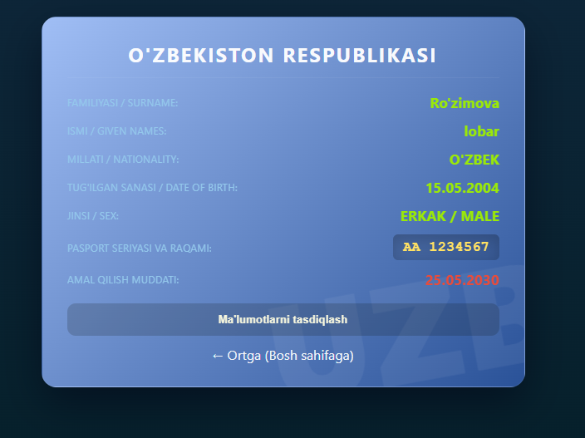

Xulosa:
CSS’da Transition va Animation elementlarini o‘rganish jarayonida zamonaviy veb-dizaynning eng muhim qismlaridan biri — dinamik interfeys yaratish tamoyillari tahlil qilindi. Olib borilgan o‘rganishlar va amaliy tajribalar asosida quyidagi yakuniy xulosalarga kelindi:

